Network locations were first introduced in Windows Vista. At that time, they felt half-baked and confusing to users. They were improved in Windows 7 and later on in Windows 8. Now they have a simple implementation and they are a very useful way to manage network connections and network sharing

A network location is a profile that includes a collection of network and sharing settings that get applied to the network you are connected to. Based on the network location assigned to your active network connection, features such as file and printer sharing, network discovery and others might be enabled or disabled

* **Home network** - choose this location when you are connected to your home network or a network with people and devices you fully trust. By default, network discovery will be turned on and you will be able to see other computers and devices which are part of the network. Also, this will allow other computers from the network to access your computer. On home networks you will be also allowed to create or join a HomeGroup.
* **Work network** - this profile is good when connecting to the network from your workplace. This profile shares the same settings with Home network. The only important difference is the fact that it won't allow you to create or join a HomeGroup.
* **Public network** - this profile is perfect when you are in a public place like an airport, hotel or coffee shop. When this profile is used, network discovery and sharing are turned off. Other computers from the same network will not be able to see yours. This setting is also useful when your computer is directly connected to the internet (direct cable/modem connection, mobile internet, etc)
* **Domain network**. This one cannot be set by a normal user. It is available for enterprise workplaces and it is set by the network administrator. The settings applied to this profile are those set by your company and you cannot change them. Also, they vary from company to company.

**How to customize network location settings**

Open Network and Sharing Center > Changed advanced sharing settings

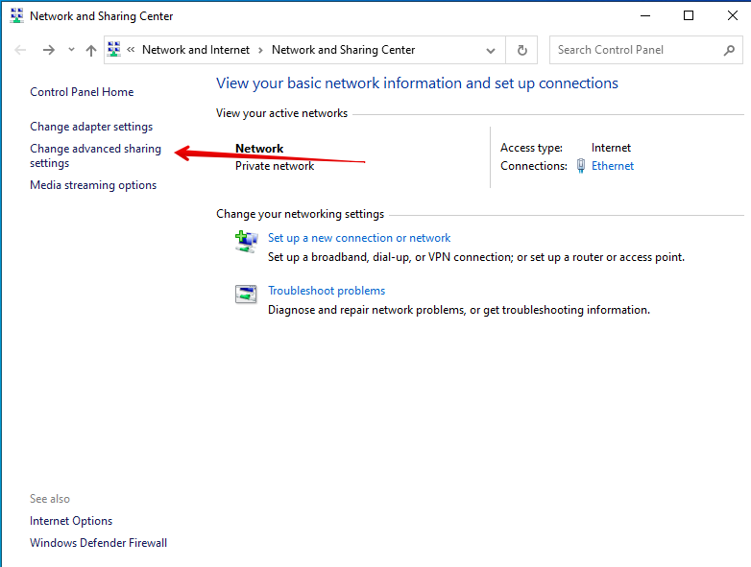

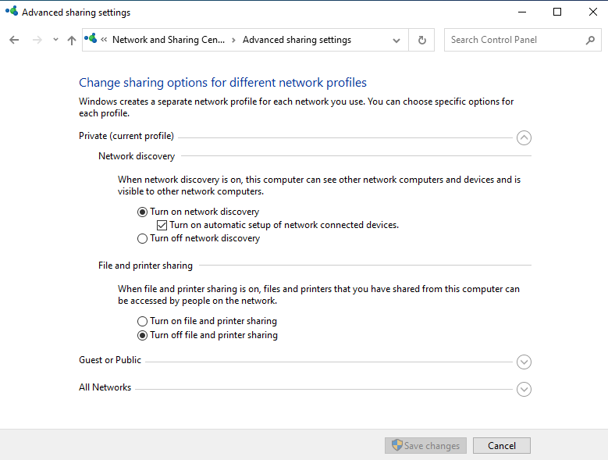

**How to change network location**

Open Settings > Network and Internet > Ethernet. Click on the Connection

